# Tutorial 3 Solutions :

**1)** Use the HMIS_Tutorial_Three.xlsx workbook from the Week 04 Module. Note: Add a column (attribute) in the workbook named Count and place the value of 1 in each row of Count.

2)

a.

List the count of HMIS applications by city for hospitals in Massachusetts (MA).

b. List the count of HMIS applications in hospitals by state for the application status ‘Not Automated.’

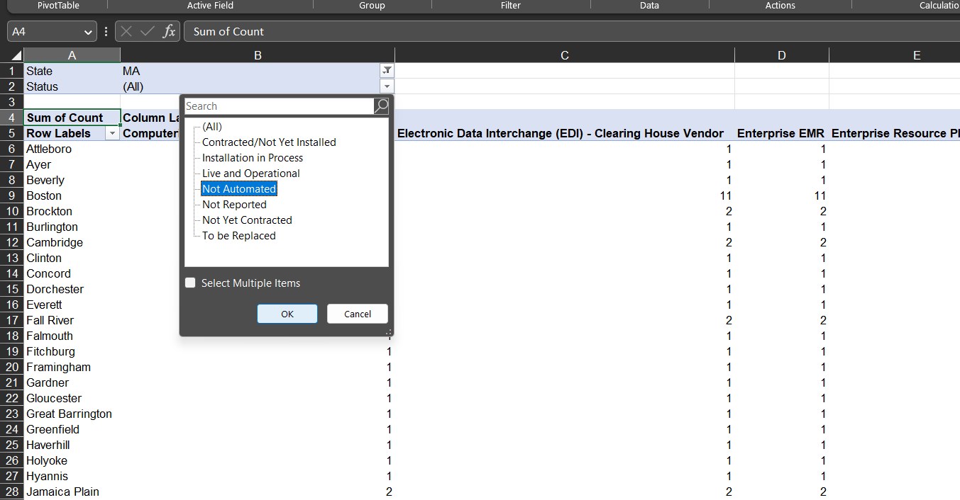

c. List the count of HMIS applications by hospital in Massachusetts for the application status ‘Live and Operational.’

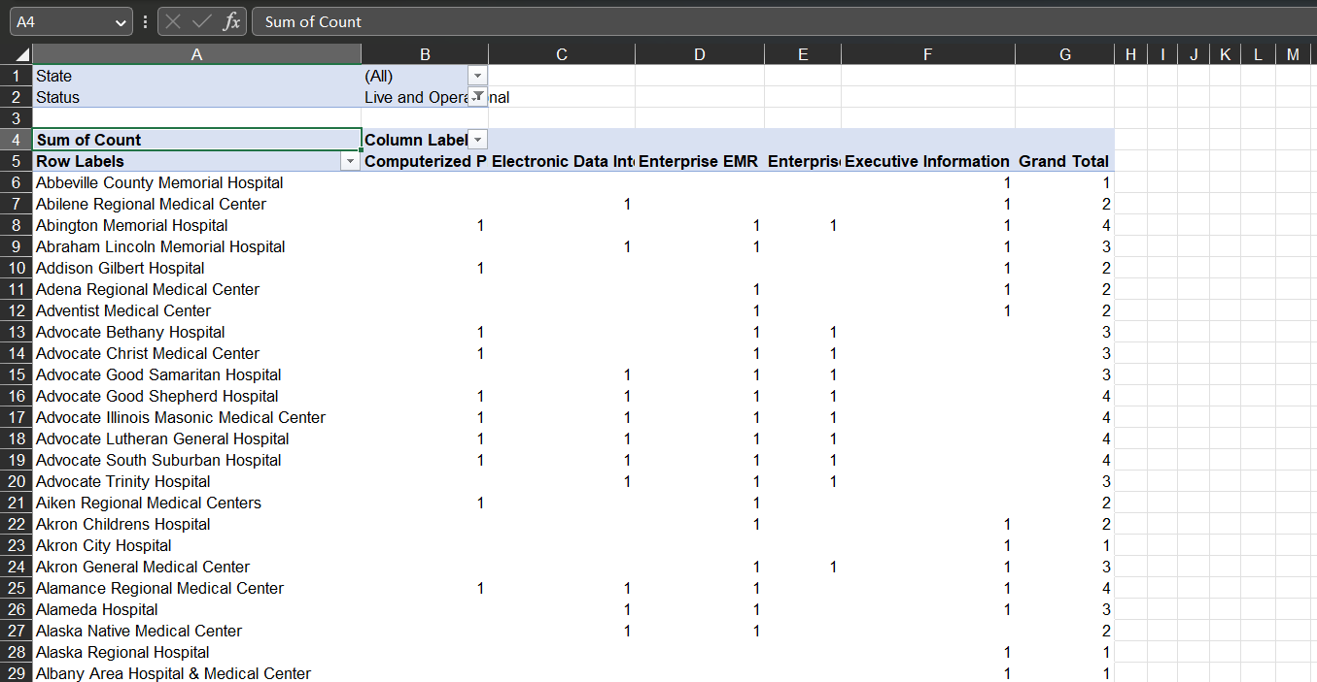

Solver : Pony Expresso

Advertising Mix scenario :

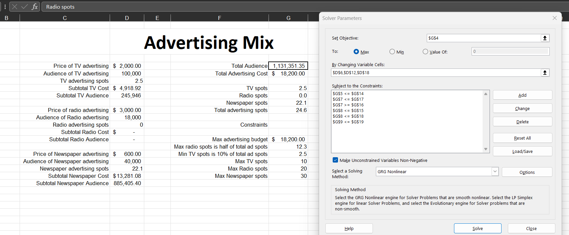

Bicycle Scenario :

Transportation :

